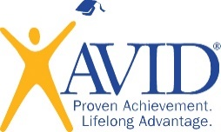
Baldivis Film Academy

APPLICATION FORM 2021 ENROLMENTS
Applications close Friday October 30, 2020

Applicant Name: _________________________________________________

Parent/Guardian Name: ___________________________________________

Address: ________________________________________________________

Mobile Phone Contact: ____________________________________________

Email Address: ___________________________________________________

Current Primary School: ___________________________________________

Please attach a copy of your most recent school report.

We understand that part of the application process will be for my child to participate in the Make a Film in Day on Friday November 13 at Baldivis Secondary College. If your child can not participate please contact Curriculum Team Leader – The Arts, Kristie Gray on 9523 3665. We have read the information brochure about the Baldivis Film Academy. It can be downloaded from our website at:
https://www.baldivissc.wa.edu.au/film-academy/

Parent/Guardian Signature: ___________________________________________________

Applicant Signature: ___________________________________________________

Date: ________________________

